SIMATS ENGINEERING

ASSESSMENT TOOL 1

COURSE NAME: Fundamentals Of Data Science COURSE CODE: DSA04

COURSE OUTCOME COVERED

CO3: Evaluate datasets using descriptive statistics, including summarization, outlier detection, and distribution analysis, and perform statistical inference through estimation and hypothesis testing. (BL3)

Assessment Tool Weightage: 20%

QUESTIONS: 10 Total Marks:100 marks
Annexure A

POSTER PRESENTATION

Code of Conduct:

I S .Aman Hussain 192425021 (Name / Reg No) certify that this submission is my original work and that I have adhered to the guidelines specified for this assessment.
I understand that any violation of academic integrity rules will result in disciplinary action.

S. Aman Hussain
Signature of the student:

RUBRICS FOR CALCULATION

 |  |  | Poster Presentation
Criteria | Weightage (%) | Level 4 (Exemplary) 5 Marks | Level 3 (Proficient) 4 Marks | Level 2 (Developing) 3 – 2 Marks | Level 1 (Beginning) 1 Marks | Level | Marks
Technical  Content  Accuracy | 30 | Highly accurate, in-depth, and insightful technical explanation | Technically correct content with adequate depth and clarity | Basic concepts presented with limited accuracy and depth | Content contains major technical errors; concepts poorly understood
Problem  Identification | 25 | Problem rigorously analyzed using appropriate and advanced methods | Problem clearly defined with a logical engineering approach | Problem identified but analysis or methodology is weak | Problem statement unclear or incorrect; no logical approach
Use of Tools | 20 | Advanced tools, well-analyzed data, and highly effective visuals | Appropriate tools and data used effectively with clear visuals | Limited use of tools and basic data interpretation | Minimal or incorrect use of tools and data; poor visuals
Communication | 15 | Highly engaging, confident, and audience-focused delivery | Clear, organized, and professional communication | Understandable but  lacks clarity, structure, or confidence | Poor organization, unclear speech, ineffective slides
Professionalism | 10 | Exemplary professionalism, leadership, and ethical awareness | Professional conduct with effective team collaboration | Basic professionalism; uneven team participation | Lacks professionalism; minimal contribution or ethical awareness

Annexure A

Question 01: University Learning Management System (LMS) Usage Analysis (100 Marks)
A university uses an online Learning Management System (LMS) to deliver course materials. Most students spend 2–4 hours per week on the platform, while a small number of students spend more than 20 hours per week. The university wants to understand student engagement patterns and identify factors affecting academic performance.
Prepare a comprehensive poster presentation that includes:
- Data summarization of LMS usage statistics.
- Analysis of the distribution of student engagement data.
- Identification and interpretation of outliers.
- Discussion on whether highly active students should be considered outliers.
- Analysis of skewness and kurtosis in LMS usage patterns.
- Relationship between LMS usage and academic performance.
- Recommendations for improving student engagement and learning outcomes. Question 02: Renewable Energy Production Analysis (100 Marks)
A solar power plant generates electricity throughout the year. On normal days, energy production ranges from 5,000 to 8,000 kWh, while on exceptionally sunny days production exceeds 12,000 kWh. During cloudy or rainy days, production may fall below 2,000 kWh.
The management wants to analyze production variability and improve energy forecasting.
Develop a poster presentation covering the following aspects:
- Summarize the energy production data using descriptive statistics.
- Examine the distribution of daily energy generation.
- Identify and analyze unusually high and low production values.
- Discuss appropriate methods for handling outliers.
- Measure and interpret skewness and kurtosis.
- Evaluate the impact of weather conditions on data distribution.
- Suggest forecasting and operational strategies to improve renewable energy management.

Question 03: E-Commerce Festival Sales Analysis (100 Marks)
An online retailer records average daily sales of ₹10 lakh. During a festival season, sales increase to ₹2 crore per day.
Develop a poster discussing:
- Summary statistics before and during the festival.
- Changes in sales distribution.
- Identification of unusual sales patterns.
- Whether festival sales should be treated as outliers.
- Interpretation of skewness and kurtosis.
- Business insights obtained from the analysis.
- Strategic recommendations for inventory planning.

Question 04: Healthcare Monitoring System (100 Marks)
A hospital continuously monitors patient heart rates using wearable sensors. Most readings are between 60–90 bpm, while some readings exceed 180 bpm.
Prepare a poster that addresses:
- Data summarization of patient health records.
- Visualization techniques for monitoring trends.
- Detection of abnormal readings.
- Methods for treating erroneous sensor values.
- Analysis of skewness and kurtosis.
- Differentiating medical emergencies from data errors.
- Recommendations for real-time healthcare monitoring.

Question 05: Cybersecurity Network Traffic Analysis (100 Marks)
A company's server typically receives 20,000 requests per hour. During a cyberattack, the traffic suddenly increases to 2 million requests per hour.
Prepare a comprehensive poster explaining:
- Methods for summarizing network traffic data.
- Traffic distribution under normal conditions.
- Detection of abnormal traffic spikes.
- Outlier treatment strategies.
- Analysis of skewness and kurtosis.
- Role of anomaly detection in cybersecurity.
- Security measures to prevent future attacks.

Question 06: Manufacturing Quality Control (100 Marks)
A manufacturing company produces 50,000 bottles daily. The target volume is 1 liter, but some bottles contain less than 900 ml or more than 1.1 liters.
Design a poster discussing:
- Data summarization techniques.
- Distribution of bottle volumes.
- Detection of defective products using outlier analysis.
- Treatment of abnormal measurements.
- Analysis of skewness and kurtosis.
- Impact on product quality and customer satisfaction.
- Recommendations for process improvement.

Question 07: Climate Change and Weather Analysis (100 Marks)
A city normally experiences temperatures between 25°C and 35°C. Over the last decade, several days recorded temperatures above 45°C.
Prepare a poster presentation covering:
- Summary statistics of temperature data.
- Distribution of climatic variables.
- Identification of extreme weather events.
- Outlier treatment considerations.
- Analysis of skewness and kurtosis.
- Implications for climate change research.
- Recommendations for policymakers.

Question 08: Social Media Engagement Analysis (100 Marks)
A content creator uploads 500 videos. Most videos receive fewer than 10,000 views, while a few viral videos receive over 10 million views.
Develop a poster explaining:
- Data summarization methods.
- Distribution of engagement metrics.
- Detection of viral-content outliers.
- Whether viral videos should be retained.
- Interpretation of skewness and kurtosis.
- Business implications for content creators.
- Strategies to improve audience engagement.

Question 09: Stock Market Volatility Analysis (100 Marks)
A stock usually fluctuates within ±2% daily. Following a major corporate announcement, the stock price rises by 30% in a single day.
Prepare a detailed poster discussing:
- Summary statistics of stock returns.
- Distribution of financial data.
- Detection of abnormal market movements.
- Treatment of extreme observations.
- Interpretation of skewness.
- Importance of kurtosis in financial risk analysis.
- Investment recommendations based on findings.

A smart city uses sensors to monitor traffic flow. The average traffic volume is 700 vehicles per hour. During a major cultural festival, traffic increases to 7,000 vehicles per hour.
Create a poster presentation that includes:
- Data summarization of traffic patterns.
- Analysis of traffic distribution.
- Identification of unusual traffic events.
- Outlier detection and treatment methods.
- Analysis of skewness and kurtosis.
- Traffic management recommendations.
- Development of a predictive model for future events.
Scenario: Most students use the LMS 2–4 h/week; a few exceed 20 h/week. Goal: understand engagement and its link to performance.
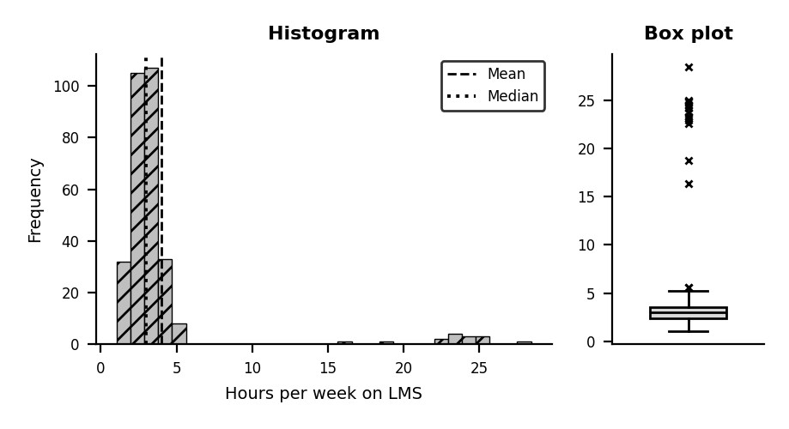
  Statistic | All students
  n | 300
  Mean | 3.99
  Median | 3.01
  Std dev | 4.56
  Min | 1.07
  Max | 28.41
  Q1 | 2.41
  Q3 | 3.58
  Skewness | 4.02
  Excess kurtosis | 15.05
  IQR outliers | 17
- Data summarization. n = 300 students; mean 4.0 h, median 3.0 h, SD 4.6 h, range 1.1–28.4 h, IQR 2.4–3.6 h. Mean > median, so a few heavy users pull the average up; the median and IQR describe a typical student better.
Q1 · University LMS Usage Analysis
- Distribution of engagement. The histogram has a tall peak at 2–4 h and a long thin tail beyond 20 h. The bulk is unimodal and bell-like, but the overall shape is right-skewed and clearly non-normal.
- Outliers. Tukey fences are [0.7, 5.3] h and flag 17 students (13 students use > 20 h). They sit far beyond the box-plot whisker and have very high z-scores; low-hour outliers are absent.
- Should highly active students be outliers? Statistically yes, practically no. They are genuine observations (repeat learners, online-heavy courses), not errors. Keep them; verify with login logs that sessions are not just idle tabs; report results with and without them or use robust/log-scale methods. Delete only confirmed tracking errors.
- Skewness and kurtosis. Skewness = 4.02 (strong right (positive) skew) and excess kurtosis = 15.05 (heavy tails, leptokurtic): extreme usage is far more common than a normal curve predicts.
- LMS usage vs performance. Pearson r = 0.67, Spearman ρ = 0.50; without heavy users r = 0.46. Mean score: 60 (< 2 h), 64 (2–4 h), 74 (≥ 4 h incl. heavy users). Usage and marks rise together with diminishing returns at very high hours. Correlation is not causation: motivated students log in more, and the 15 heavy users have high leverage on r.
- Recommendations. Send nudges to low-usage students; add short videos, quizzes and discussion forums; build early-alert dashboards using median-based thresholds; create peer study groups; check heavy users for difficulty or burnout; track engagement quality (quiz attempts, completion), not just time online.
KEY TAKEAWAY: The median describes the typical learner; heavy users are valid data to keep. Engagement quality matters more than raw hours.
Q2 · Renewable Energy Production Analysis
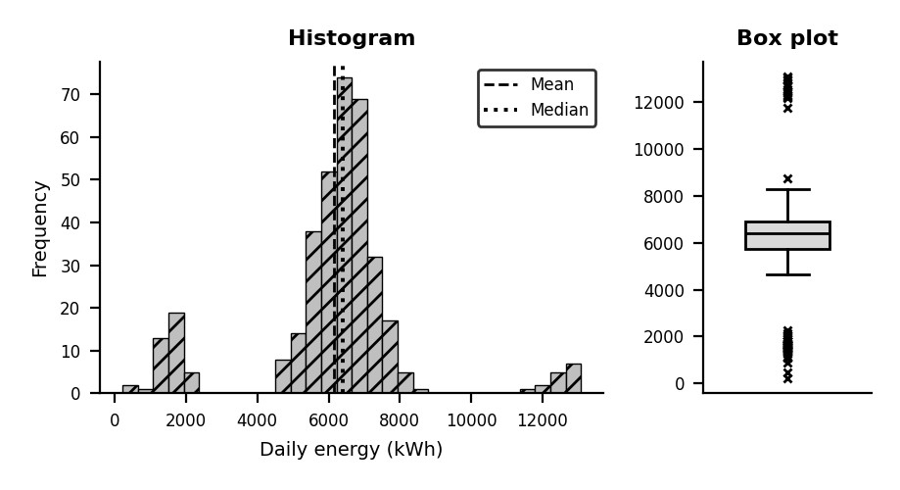
  Statistic | 365 days
  n | 365
  Mean | 6,161
  Median | 6,401
  Std dev | 2,130
  Min | 223.1
  Max | 13,075
  Q1 | 5,742
  Q3 | 6,906
  Skewness | 0.01
  Excess kurtosis | 2.97
  IQR outliers | 56
- Descriptive statistics. n = 365 days; mean 6,161 kWh, median 6,401, SD 2,130, min 223.1, max 13,075, quartiles 5,742 / 6,906 kWh. Median is the best 'typical day'; SD is inflated by weather extremes.
- Distribution of generation. A large central mode at 5,000–8,000 kWh plus two small satellite clusters (sunny > 12,000 and cloudy < 2,000). The data form a mixture of three weather regimes, not a single normal curve.
- High and low values. Fences [3,997, 8,651] flag 56 days: 14 days above 12,000 kWh and 36 days below 2,000 kWh. Low values need a cause check: weather or equipment fault (inverter outage, grid curtailment).
- Handling outliers. Do not delete: they are real events. Options: (a) segment by weather class and model each; (b) winsorize at 1st/99th percentile for summary reports only; (c) robust statistics (median, MAD); (d) Box-Cox/log transform; (e) cross-check low days with irradiance and SCADA logs to separate faults from weather.
- Skewness and kurtosis. Skewness = 0.01, near zero because the long low tail (cloudy days) and the high tail (sunny days) roughly offset each other, so skewness alone hides the extremes. Excess kurtosis = 2.97: tails are heavier than normal, so extreme days are more likely than a bell curve suggests.
- Impact of weather. Cloud/rain pulls output into the left tail; clear, cool, high-irradiance days push it into the right tail. Weather changes the mean and variance of the process, so a single distribution is invalid. Use irradiance, cloud cover and temperature as covariates.
- Forecasting and operations. Weather-aware models (regression on irradiance, SARIMA, gradient boosting, LSTM); probabilistic (quantile) forecasts; battery storage and reserve capacity for < 2,000 kWh days; day-ahead scheduling; panel cleaning and predictive maintenance; demand-response agreements.
KEY TAKEAWAY: Output variability is weather-driven. Segment by weather, use probabilistic forecasts, and plan storage for the low tail.

Q3 · E-Commerce Festival Sales Analysis
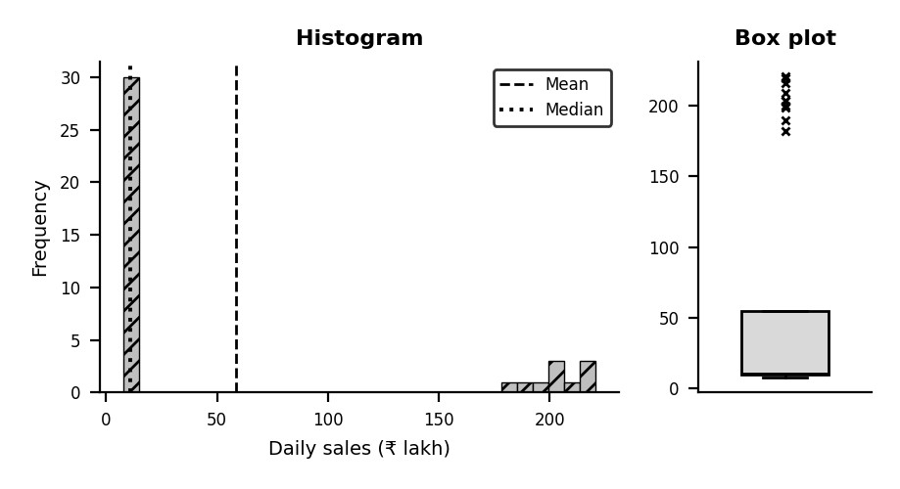
  Statistic | Before | Festival | Combine d
  n | 30 | 10 | 40
  Mean | 10.06 | 204.1 | 58.56
  Median | 10.19 | 203.1 | 10.68
  Std dev | 1.35 | 12.55 | 85.30
  Min | 7.70 | 181.8 | 7.70
  Max | 12.69 | 220.6 | 220.6
  Q1 | 9.30 | 198.9 | 9.57
  Q3 | 10.94 | 214.1 | 54.96
  Skewness | -0.09 | -0.28 | 1.17
  Excess kurtosis | -0.76 | -0.82 | -0.60
  IQR outliers | 0 | 0 | 10
- Summary statistics. Before festival (30 days): mean ₹10.1 lakh, SD 1.4. Festival (10 days): mean ₹204 lakh, SD 13. Sales rise about 20× and spread grows about 9×. Combined mean (59) matches neither period, so it is misleading.
- Change in distribution. Before: narrow and roughly symmetric around ₹10 lakh. Festival: whole distribution shifts far right with much larger variance. Combined data become bimodal (two separate clusters).
- Unusual patterns. Combined fences [-59, 123] flag 10 days, all festival days. Also look for pre-festival ramp-up, weekend peaks, flash-sale hours and the sudden post-festival drop.
- Are festival sales outliers? No, not in the error sense. They come from a different, known regime (a planned event). Keep them, tag with a festival flag, and analyse the two regimes separately. Outliers are judged against the festival's own distribution (e.g., a day > 3 SD above the festival mean).
- Skewness and kurtosis. Combined: skewness 1.17 (right (positive)), excess kurtosis -0.60. Within each regime they are close to zero (skew -0.09 before, -0.28 festival), so the strong shape is created by mixing two populations.
- Business insights. Festival revenue is about 20× baseline, so revenue is event-driven and concentrated in a few days. A single average is useless for planning. Warehouse, logistics, payment and server capacity must be sized for the festival regime, not the average.
- Inventory strategy. Forecast festival demand separately (last year × growth); set safety stock from festival SD at a 95–99 % service level; pre-position stock in regional warehouses; use supplier agreements for quick replenishment; monitor sales in real time to rebalance; plan clearance to avoid dead stock.
KEY TAKEAWAY: Festival days are a separate regime, not errors. Plan inventory with regime-specific statistics, never the blended mean.

Q4 · Healthcare Monitoring System
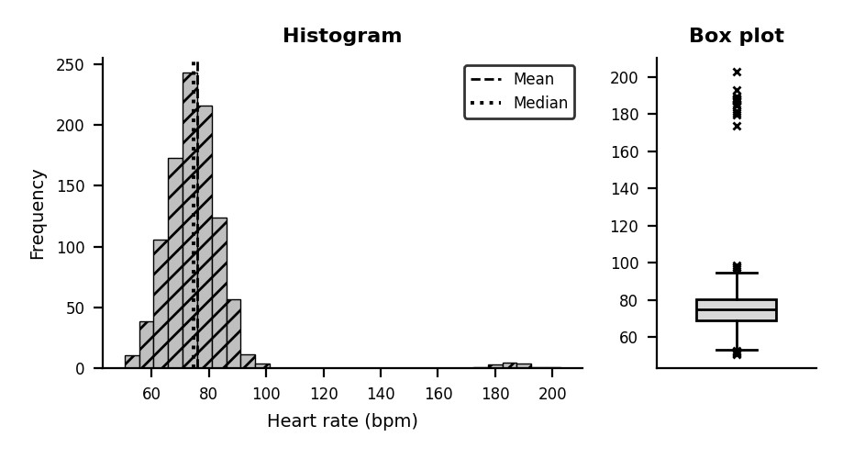
  Statistic | Readings
  n | 1000
  Mean | 75.99
  Median | 74.74
  Std dev | 15.87
  Min | 50.62
  Max | 202.7
  Q1 | 69.16
  Q3 | 80.08
  Skewness | 5.02
  Excess kurtosis | 33.17
  IQR outliers | 24
- Data summarization. n = 1000 readings; mean 76.0 bpm, median 74.7, SD 15.9, range 51–203.
Summaries per patient and per time window (min, max, median, % time outside 60–100 bpm) are more useful than one global mean.
Visualization techniques. Line chart with rolling median band; control chart with 60–100 bpm limits; histogram and box plot (shown); per-patient heat map by hour; scatter of heart rate vs activity; live dashboard with colour-free symbols/alert icons.
- Abnormal readings. Tukey fences [53, 96] bpm flag 24 readings (13 above 180 bpm). Also use z-score, clinical rule thresholds, Hampel filter on a rolling window, and Isolation Forest for multivariate vitals.
- Treating erroneous values. Flag physiologically impossible values (< 20 or > 250 bpm), sudden jumps (> 40 bpm in 1 s), flat-lines and dropouts. Remove or mark them, then impute using rolling median/interpolation or a Kalman filter. Always keep the raw log for audit.
- Skewness and kurtosis. Skewness = 5.02 (right (positive) tail from high spikes); excess kurtosis = 33.17 (heavy tails). A normal-based alarm limit would be unreliable; use robust limits.
- Emergency vs data error. Emergency: sustained elevation over many consecutive readings, smooth rise and fall, confirmed by other vitals (SpO₂, BP, ECG) and symptoms. Sensor error: isolated abrupt spike, implausible value, motion artefact (accelerometer shows movement), other vitals normal, vanishes on re-attaching.
- Real-time monitoring recommendations. Streaming pipeline with filtering; multi-sensor fusion; tiered alerts (check sensor → nurse → doctor); patient-specific adaptive thresholds (age, activity); redundant sensors; calibration schedule; alarm-fatigue control; encrypted data and privacy compliance.
KEY TAKEAWAY: Never ignore a high reading: confirm it against other signals first. Filter errors, but escalate sustained abnormal patterns immediately.

Q5 · Cybersecurity Network Traffic Analysis
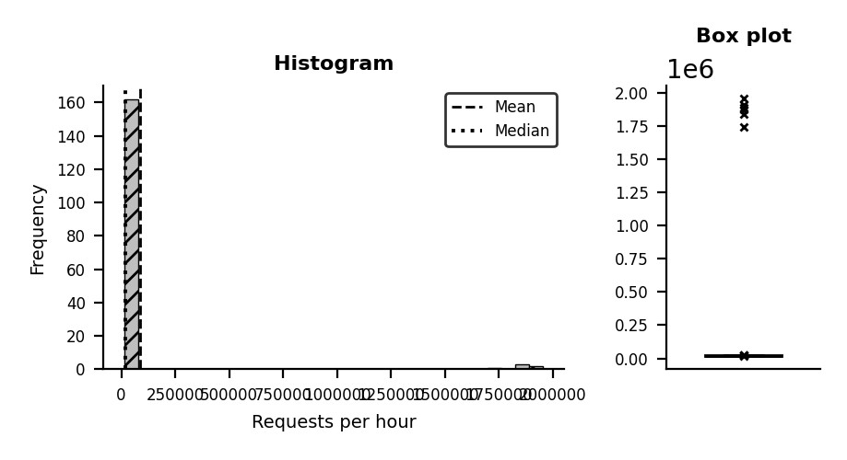
  Statistic | 168 hours
  n | 168
  Mean | 86,132
  Median | 20,290
  Std dev | 344,120
  Min | 14,796
  Max | 1,955,052
  Q1 | 18,971
  Q3 | 21,329
  Skewness | 5.01
  Excess kurtosis | 23.18
  IQR outliers | 10
Summarizing traffic data. n = 168 hours; mean 86,132, median 20,290, SD 344,120, max 1,955,052. Mean is dragged far above median by the attack. Aggregate per minute/hour; track percentiles (p95, p99), requests per IP, per endpoint and per status code.
- Normal traffic distribution. Baseline hours (excluding attack) are bell-shaped: mean 20,148, SD 1,898, with a daily cycle (business-hour peak). Roughly normal or Poisson-like; seasonality should be modelled.
- Detecting spikes. Attack-hour traffic is about 99× baseline, a z-score of 1043 against the baseline. Fences [15,434, 24,867] flag 10 hours. Use rolling z-score, EWMA/CUSUM control charts and rate-of-change alerts.
- Outlier treatment. Do not delete; the attack is the event of interest. Learn the baseline only from clean windows; use median/MAD for robust limits; cap or log-scale for plotting; save the attack window for forensics; rate-limit or block offending sources.
- Skewness and kurtosis. Skewness = 5.0 (right (positive)) and excess kurtosis = 23.2: extreme values of this size cannot come from a normal distribution; very high kurtosis signals rare, huge spikes.
- Role of anomaly detection. Provides early warning beyond fixed thresholds. Methods: statistical (z-score, MAD), machine learning (Isolation Forest, autoencoder, one-class SVM). It helps separate a flash crowd (varied users, long sessions) from a DDoS (many similar sources, short sessions), and feeds SIEM alerts.
- Preventive security measures. WAF; rate limiting; CDN and DDoS scrubbing service; load balancers with auto-scaling; IP reputation filtering; CAPTCHA on sensitive pages; IDS/IPS; timely patching; incident-response plan with regular drills; continuous monitoring and log retention.
KEY TAKEAWAY: A 100× jump is an anomaly worth an alert, not a value to delete. Combine statistical baselines with ML detection and layered defences.

Q6 · Manufacturing Quality Control
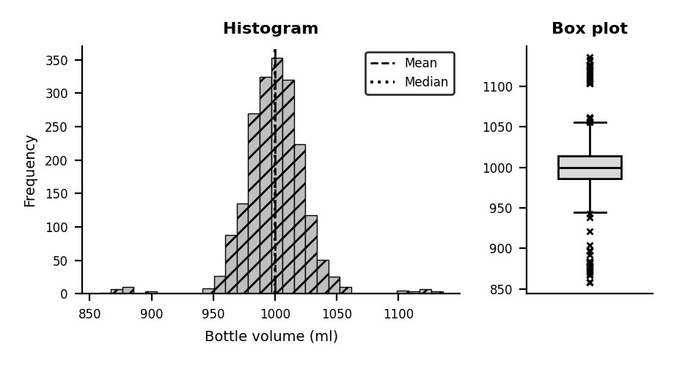
  Statistic | Sample
  n | 2000
  Mean | 1,000
  Median | 1,000
  Std dev | 26.59
  Min | 857.9
  Max | 1,136
  Q1 | 986.3
  Q3 | 1,014
  Skewness | -0.21
  Excess kurtosis | 7.37
  IQR outliers | 53
- Data summarization. n = 2000 sampled bottles; mean 1000.0 ml, median 1000.2, SD 26.6, range 858–1136 ml. Also use X-bar and R charts, histograms, defect rate (%) and process capability Cp = 1.25, Cpk = 1.25.
- Distribution of volumes. A sharp bell curve centred near 1,000 ml with small tails on both sides. The process is centred, so the mean is on target; the spread and the tails are the quality concern.
- Defect detection by outliers. Specification limits 900–1,100 ml: 23 bottles under 900 ml and 20 over 1,100 ml, i.e. 2.1 % defective. IQR fences [945, 1056] and ±3σ control limits also flag unusual bottles.
- Treating abnormal measurements. Classify first: measurement error (re-measure, calibrate gauge) or genuine defect. Under-filled: reject or refill. Over-filled: giveaway loss, recalibrate the filler. Keep records and run root-cause analysis (fishbone, 5 Whys).
- Skewness and kurtosis. Skewness = -0.21 (almost symmetric: under-fill and over-fill balance out). Excess kurtosis = 7.37 (heavier tails than normal: more extreme bottles than the main bell predicts).
- Quality and customer impact. At 2.1 % defective, about 1,075 of 50,000 daily bottles are out of tolerance. Under-fill breaches labelling rules and trust; over-fill wastes product; both raise complaints, returns and brand damage.
- Process improvement. Statistical process control with live charts; automated inline volume sensors or vision checks; filler calibration and preventive maintenance; operator training; Six Sigma DMAIC; supplier QA; sampling plans with automatic rejection of out-of-spec bottles.
KEY TAKEAWAY: The average is on target, but tail defects drive the quality problem. Monitor spread and tails with SPC, not just the mean.

Q7 · Climate Change and Weather Analysis
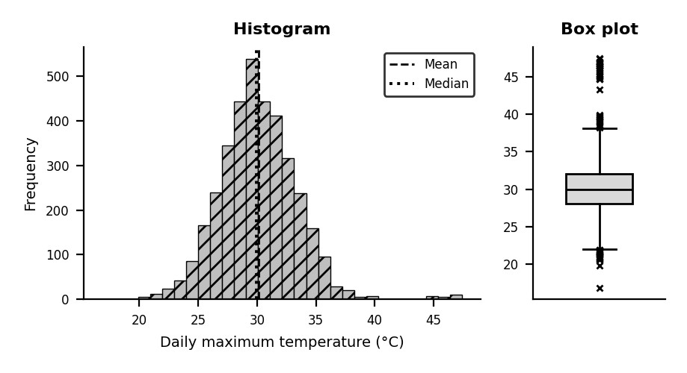
  Statistic | 10 years
  n | 3650
  Mean | 30.11
  Median | 29.96
  Std dev | 3.29
  Min | 16.83
  Max | 47.44
  Q1 | 28.04
  Q3 | 32.07
  Skewness | 0.67
  Excess kurtosis | 2.98
  IQR outliers | 58
- Summary statistics. n = 3650 days; mean 30.1 °C, median 30.0, SD 3.3, min 16.8, max 47.4. Also compute yearly means, 95th/99th percentiles and number of days > 35 °C (212), > 40 °C (25) and > 45 °C(20).
Distribution of climate variables. Bell-shaped for normal days (about 25–35 °C) with a thin right tail of extreme heat. Compare first and last years of the decade to see whether the whole distribution is shifting or only the tail is growing.
- Extreme weather events. Fences [22.0, 38.1] °C flag 58 days. 20 days exceed 45 °C. Identify heat waves as consecutive hot days, percentile exceedance (> 95th) and return periods using Extreme Value Theory (GEV/GPD).
- Outlier treatment considerations. Do not remove: they are the climate signal itself. First verify against nearby stations and satellite data to rule out sensor faults; then keep them, use robust statistics for 'normal' climate and extreme-value models for the tail.
- Skewness and kurtosis. Skewness = 0.67 (right (positive) tail from heat extremes); excess kurtosis =2.98: heavy tails mean extremes are far more frequent than a normal model suggests.
- Implications for climate research. Rising frequency and intensity of extremes show a non-stationary climate: past 'normal' no longer predicts the future. Averages understate risk; tail indicators, trend tests (Mann-Kendall) and attribution studies are needed. Impacts: health, power demand, crops, water.
- Recommendations for policymakers. Heat action plans and early-warning alerts; cooling centres and care for vulnerable groups; urban greening and cool roofs; heat-resilient building codes; power and water planning for peak demand; emission-reduction commitments; long-term open monitoring data.
KEY TAKEAWAY: Extreme-heat days are a real climate signal. Keep them, model the tail separately, and plan policy for a shifting distribution.

Q8 · Social Media Engagement Analysis
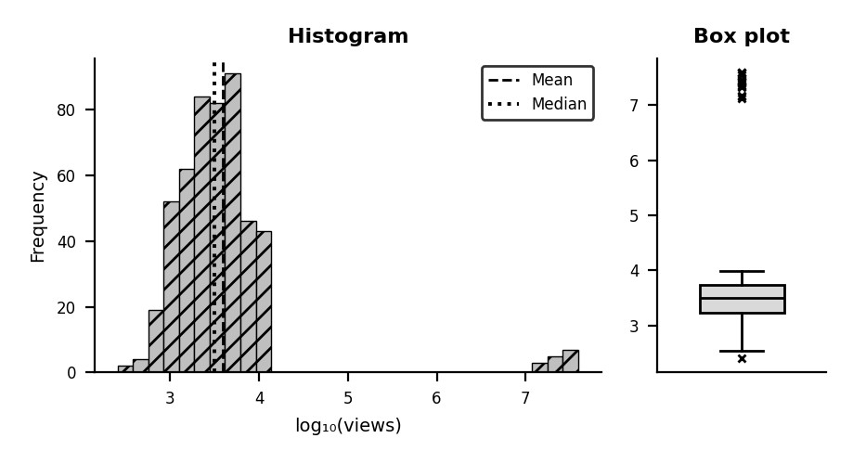
  Statistic | 500 videos
  n | 500
  Mean | 785,540
  Median | 3,147
  Std dev | 4,679,597
  Min | 255.7
  Max | 39,029,082
  Q1 | 1,743
  Q3 | 5,471
  Skewness | 6.32
  Excess kurtosis | 40.55
  IQR outliers | 15
- Data summarization. n = 500; mean 785,540 views but median only 3,147; 4,679,597; max39,029,082. Mean is misleading; report median, quartiles (1,743 / 5,471), trimmed mean and geometric mean.Distribution of engagement. Extremely right-skewed with a long tail (typical of 'rich-get-richer' content popularity). On a raw scale nearly all bars pile up near zero, so the histogram shown uses a log₁₀ scale, where the bulk looks bell-shaped.
- Detecting viral outliers. Upper fence = 11,064 views; 15 videos exceed it (15 with > 10 million). Confirm with z-score on log views or median ± k·MAD. Cross-check traffic source and watch time to exclude bot or purchased views.
- Should viral videos be retained? Yes. They are real, valuable and informative. Retain them but report typical performance using median or log-scale metrics, and analyse them as a separate group. Remove only views proven fake (click farms, bots).
- Skewness and kurtosis. Raw views: skewness 6.3 (right (positive)), excess kurtosis 40.6, i.e. a few huge values dominate. The log transform cuts skewness to 3.89; the non-viral videos alone have log skewness -0.26 (near-normal), while viral videos stay a separate far cluster.
- Business implications. The top 15 videos (3 %) generate 99.5 % of all views, so income is concentrated and unpredictable. Do not forecast revenue with the mean; use median reach for sponsor deals, diversify content, and invest in learning what drives virality.
- Strategies to improve engagement. Study viral videos (title, thumbnail, hook, length, posting time); A/B test thumbnails; post consistently; use SEO and hashtags; collaborate with other creators; reply to comments; analyse audience retention; repurpose long videos into short clips; build recurring series.
KEY TAKEAWAY: A handful of viral hits drive the totals. Keep them, but judge everyday performance by the median and log-scale metrics.

Q9 · Stock Market Volatility Analysis
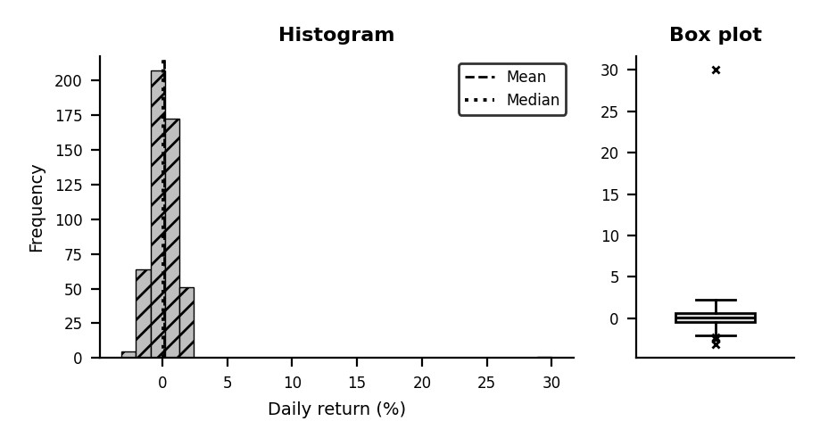
  Statistic | 500 days
  n | 500
  Mean | 0.15
  Median | 0.09
  Std dev | 1.60
  Min | -3.13
  Max | 30.00
  Q1 | -0.44
  Q3 | 0.69
  Skewness | 12.87
  Excess kurtosis | 238.12
  IQR outliers | 5
- Summary statistics of returns. n = 500 days; mean 0.15 %, median 0.09 %, SD 1.60 %, min -3.1 %, max
30.0 %. Annualized volatility ≈ SD × √252 = 25.5 %. Without the jump, SD is 0.89 %.
- Distribution of financial data. Returns are bell-shaped around zero with most days inside ±2 %, but real return data usually have fatter tails than a normal curve. One extreme positive day sits far from the cluster.
- Abnormal market movement. The +30 % day has a z-score of about 34 relative to normal days (fences [-2.1, 2.4] %). Use an event study: abnormal return = actual − expected (market model). Verify it is real news, not a split or data error.
- Treating extreme observations. It is event-driven, so keep it for risk analysis. For estimating everyday volatility, report results with and without it, winsorize, or add an event dummy; use GARCH models for volatility clustering. Adjust for splits/dividends first.
- Interpretation of skewness. Skewness = 12.87 (right (positive)): a single large gain makes the right tail longer. Positive skew means occasional big gains; negative skew (crashes) is the dangerous version. Skew from one event is unstable evidence.
- Kurtosis in risk analysis. Excess kurtosis = 238.1 (very fat tails). High kurtosis means extreme moves are far more likely than a normal model predicts, so normal-based VaR underestimates risk. Use Student-t or EVT, Expected Shortfall and stress tests.
- Investment recommendations. Do not chase a 30 % jump: price may mean-revert; check fundamentals behind the news. Diversify, size positions by risk, use stop-loss or hedging (options), measure risk with ES not just SD, and keep a long horizon. Educational analysis, not financial advice.
KEY TAKEAWAY: Extreme returns are rare but dominate risk. Kurtosis, not just the standard deviation, should guide risk limits.

Q10 · Smart City Traffic Management System
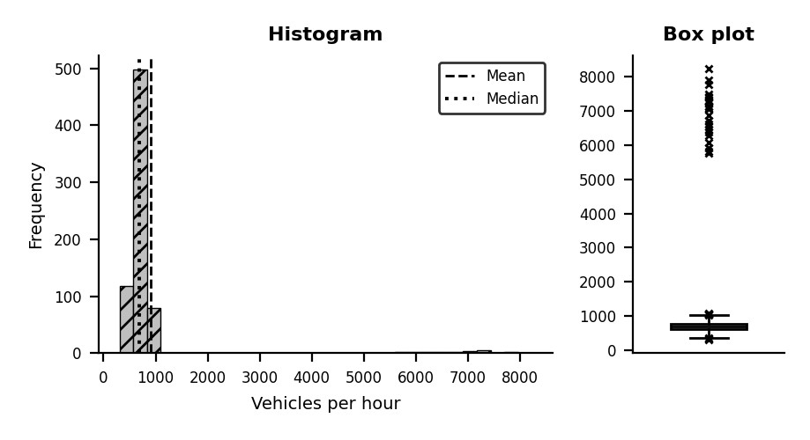
  Statistic | 720 hours
  n | 720
  Mean | 899.4
  Median | 693.7
  Std dev | 1,130
  Min | 308.4
  Max | 8,235
  Q1 | 615.7
  Q3 | 783.3
  Skewness | 5.19
  Excess kurtosis | 25.66
  IQR outliers | 32
- Data summarization. n = 720 hours; mean 899, median 694, SD 1130, max 8235 vehicles/h. Summaries by hour-of-day, weekday/weekend and event/non-event; peak-hour factor and congestion percentiles (p95).
- Traffic distribution. Normal hours form a bell around 700 vehicles/h with rush-hour cycles. Festival hours form a second, distant cluster near 7,000 (about 10× baseline), so the full data are bimodal.
- Unusual traffic events. Fences [364, 1035] flag 32 festival hours. Distinguish planned events (calendar-known) from incidents (accidents, road closures) and sensor faults (zero counts, flat-lines).
- Outlier detection and treatment. Detect with IQR, z-score, rolling median and STL seasonal-decomposition residuals. Treatment: keep festival hours with an event flag; remove or impute only sensor faults; train separate models for normal and event traffic; log-transform if needed.
- Skewness and kurtosis. Skewness = 5.19 (right (positive)) and excess kurtosis = 25.66: caused by the festival cluster. Within normal hours both are close to zero.
- Traffic management recommendations. Dynamic signal timing; diversion routes and temporary one-way streets; park-and-ride and extra public transport; real-time info via apps and variable message signs; traffic police deployment; pedestrian-only zones; pre-event capacity planning.
- Predictive model for future events. Features: hour, weekday, holiday/event flag, expected attendance, weather, lag and rolling-mean traffic. Models: SARIMAX/Prophet with event regressor, gradient boosting, LSTM. Time-based train/test split; evaluate MAE, RMSE, MAPE; retrain regularly; deploy on streaming sensor data with scenario simulation (event ≈ 10× baseline).
KEY TAKEAWAY: Festival traffic is a predictable regime. Flag events, forecast them separately, and act before congestion builds.

